**K.SANTHANALAKSHMI**

**129**

**Line chart in R**

# Create the data for the chart.

v <- c(7,12,28,3,41)

t <- c(14,7,6,19,3)

# Give the chart file a name.

#png(file = "line_chart_2_lines.jpg")

# Plot the bar chart.

plot(v,type = "o",col = "red", xlab = "Month", ylab = "Rain fall",

main = "Rain fall chart")

lines(t, type = "o", col = "blue")

# Save the file.

#dev.off()

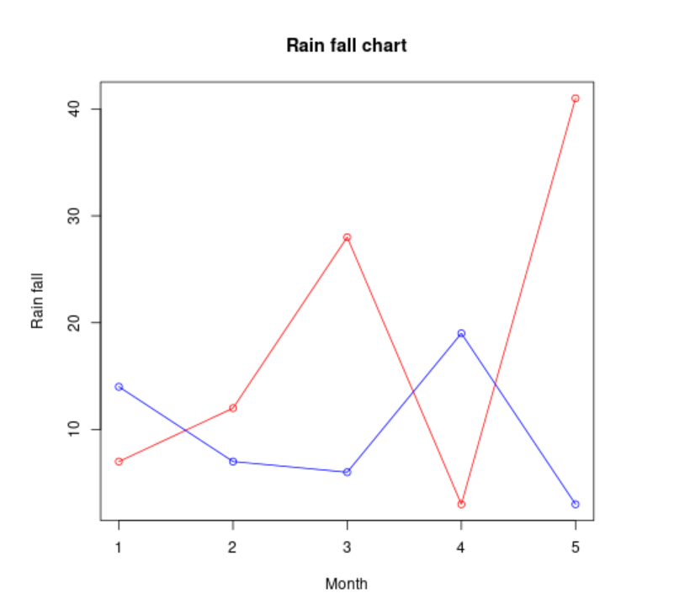

**Pie chart in R**

# Create data for the graph.

x <- c(21, 62, 10,53)

labels <- c("London","New York","Singapore","Mumbai")

piepercent<- round(100*x/sum(x), 1)

# Plot the chart.

pie(x, labels = piepercent, main = "City pie chart",col = rainbow(length(x)))

legend("topright", c("London","New York","Singapore","Mumbai"), cex = 0.8,

fill = rainbow(length(x)))

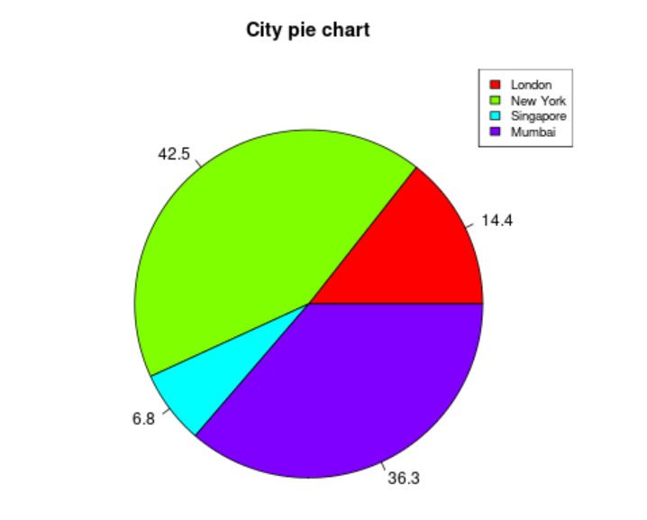

**Bar chart in R**

# Create the data for the chart

H <- c(7,12,28,3,41)

M <- c("Mar","Apr","May","Jun","Jul")

# Plot the bar chart

barplot(H,names.arg=M,xlab="Month",ylab="Revenue",col="blue",

main="Revenue chart",border="red")

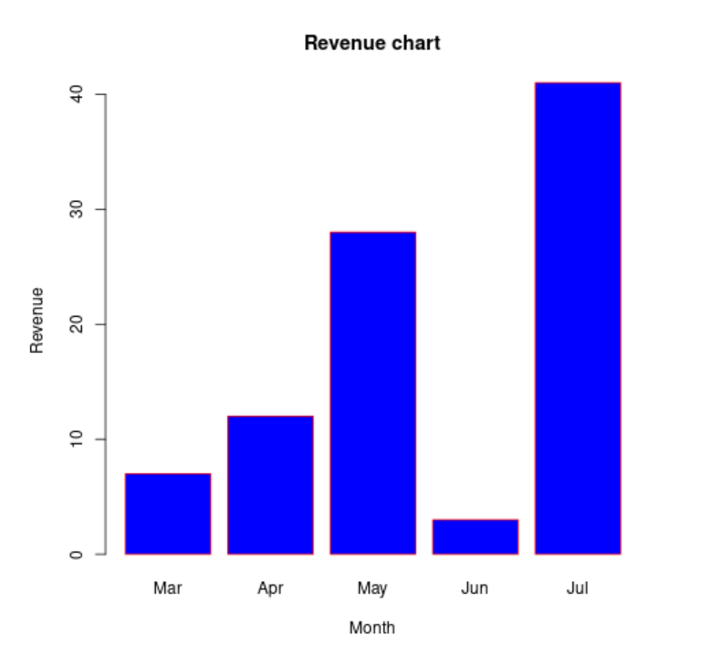

**Stacked Bar chart in R using a matrix**

# Create the input vectors.

colors = c("green","orange","brown")

months <- c("Mar","Apr","May","Jun","Jul")

# Create the matrix of the values.

Values <- matrix(c(2,9,3,11,9,4,8,7,3,12,5,2,8,10,11), nrow = 3, ncol = 5, byrow = TRUE)

# Create the bar chart

barplot(Values, main = "total revenue", names.arg = months, xlab = "month", ylab = "revenue", col = colors)

# Add the legend to the chart

regions <- c("East","West","North")

legend("topleft", regions, cex = 1.3, fill = colors)

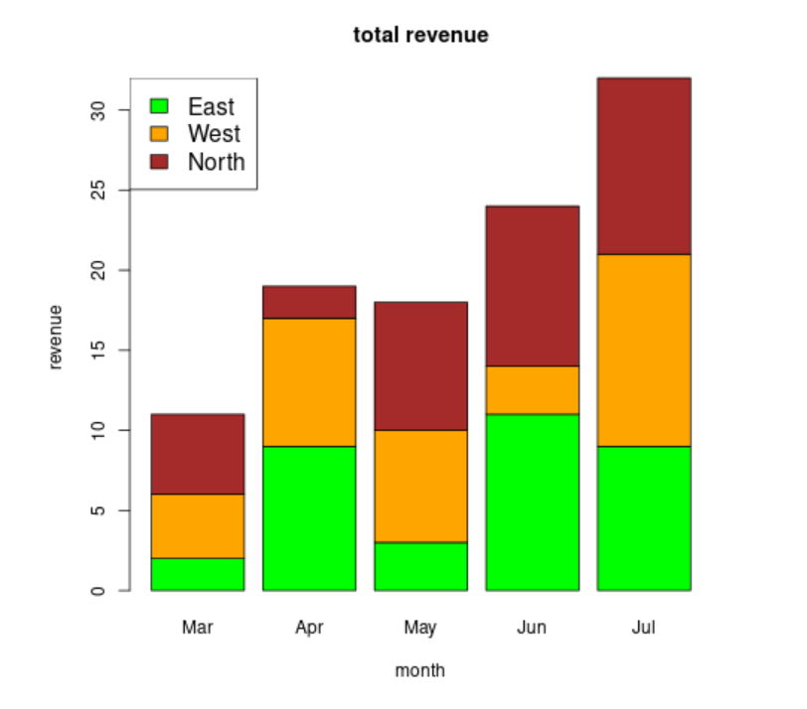

**Histogram**

v <- c(9,13,21,8,36,22,12,41,31,33,19)

hist(v,xlab = "Weight",col = "green",border = "red", xlim = c(0,40), ylim = c(0,5),

breaks = 5)

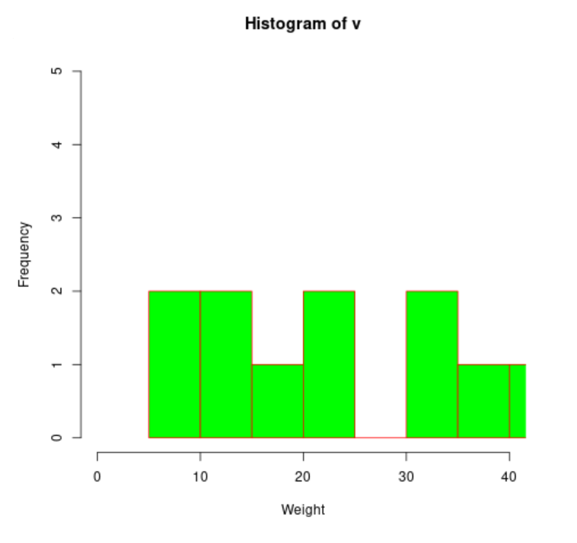

**Heat map in R**

heatmap(as.matrix(mtcars),

Rowv=NA,

Colv=NA,

col = heat.colors(256),

scale="column",

margins=c(2,8),

main = "Car characteristics by Model")

